TestNG itself is enough for parallel testing. Grid is not for Parallel testing. It is for distributing tests into multiple systems.

Request is sent to HUB.

HUB will distribute it to nodes for pallel testing or sequential testing.

Need to set up Hub and Node

Run this to start selenium grid

For same node

Java -jar selenium-server-4.8.0.jar standalone

Now enter this url to see grid up and running

Driver = new RemoteWebDriver(new URL, cap);

Now you can run the test using TestNG.

IF you want to create hub and node

Java -jar selenium-server-4.8.0.jar hub

Open another cmd and run this to create node

Java -jar selenium-server-4.8.0.jar node -I “firefox”

Create another node for chrome

Open another cmd and run this to create node

Java -jar selenium-server-4.8.0.jar node -I “chrome” -p5556

Now it shows 2 nodes as below

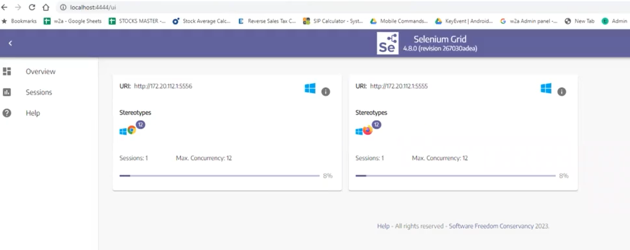

This is To save on infrastructure.

If you configure virtual machine in local system , it will slow down your system

So in order to create hundreds of virtual machines, we can use docker. It provides containers.

It is very light environment,

Developer create container and asks the tester to run his test on this, if defect is not reproducible.